PUBLIC NOTICE
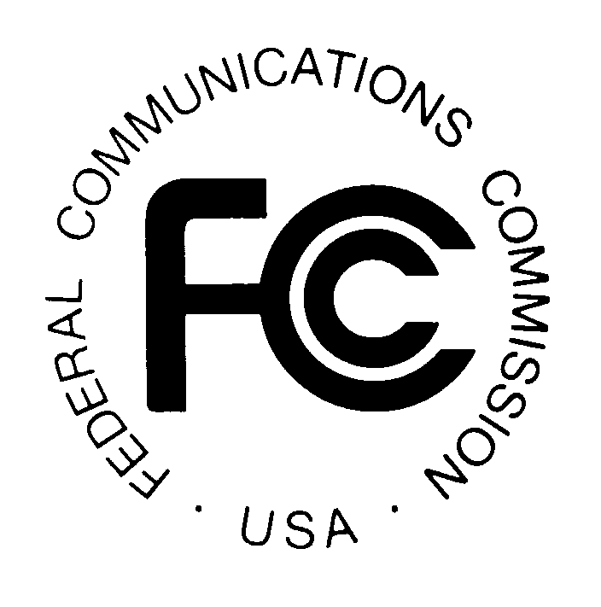
FEDERAL COMMUNICATIONS COMMISSION News Media Information: (202) 418-0500
445 12th STREET, S.W. Fax-On-Demand: (202) 418-2830

WASHINGTON, D.C. 20554 Internet: http://www.fcc.gov

ftp.fcc.gov

DA 01-1756
Released: July 25, 2001

ENFORCEMENT BUREAU FIELD OPERATIONS

LIST OF ACTIONS TAKEN

The following is a list of actions taken by the Enforcement Bureau’s Field Offices during the period June 1, to June 30, 2001. During this period, the Field Offices issued one (1) Notice of Apparent Liability (“NAL”), 60 Notices of Violation (“NOVs”) and two (2) Citations for violations of the Communications Act of 1934, as amended, 47 U.S.C. § 151, et seq., and/or the FCC’s Rules. This list is provided for information purposes only and does not provide parties with additional rights. Parties wishing to make a payment or file a response to a NAL or to file a response to a NOV or Citation must do so in accordance with the instructions and by the deadline set forth in the NAL, NOV or Citation.

NOTICES OF APPARENT LIABILITY

47 C.F.R. Part 76 – Cable and Multichannel Video Distribution Services

- 47 C.F.R. § 76.605 – Technical Standards

- James Cable Partners, LP, D/BA/ CommuniComm Services, Akron, CO. $8,000 NAL. Other violation: 47 C.F.R. § 76.611 (Cable Television Basic Signal Leakage Performance Criteria). Denver, CO District Office (6/1/01).

NOTICES OF VIOLATION

47 C.F.R. Part 1 – Practice and Procedure

- 47 C.F.R. § 1.89 – Failure to Respond to Notice of Violation

- Natural Gas Pipeline of America, Hartwell, NE. Kansas City, MO District Office (6/22/01).

- 47 C.F.R. § 1.903 – Authorization Required

- A Smith Bowman Distillery Inc. Fredericksburg, VA. Other violation: 47 C.F.R. § 90.437 (Posting Station Licenses). Columbia, MD District Office (6/1/01).
- Howard County Cab, WPRV860, Jessup, MD. Columbia, MD District Office (6/1/01).
- Rotondo Precast of Fredericksburg, Fredericksburg, VA. Columbia, MD District Office (6/1/01).

Southern Auto Body, Inc. Fredericksburg, VA. Columbia, MD District Office (6/1/01).
- Morris Communications Inc. d.b.a. AAA Paging Company, Greenville, SC. Atlanta, GA District Office (6/4/01).

47 C.F.R. Part 11 – Emergency Alert System

- 47 C.F.R. § 11.15 – EAS Operating Handbook

- Edmission & Eubank Communications, Inc., WDKN(AM), Dickson, TN. Other violations: 47 C.F.R. §§ 17.4(a) (Antenna Structure Registration), 73.51 (Determining Operating Power), 73.1230 (Posting of Station License), and 73.1400 (Transmission System Monitoring). Atlanta, GA District Office (6/18/01).
- Wilson Broadcasting Co., Inc., WAGF(AM), Dothan, AL. Other violations: 47 C.F.R. §§ 11.52 (EAS Code and Attention Signal Monitoring Requirements), 73.1230 (Posting of Station License), 73.1350 (Transmission System Operations), 73.1400 (Transmission System Monitoring), 73.1690 (Modification of Transmission Systems), 73.1745 (Unauthorized Operation) and 73.1820 (Station Log). Atlanta, GA District Office (6/18/01).
- Christian Broadcasting Group, Ceiba, PR. Other violations: 47 C.F.R. §§ 11.61 (Tests of EAS Procedures), 73.1230 (Posting of Station License), 73.1800 (General Requirements Related to the Station Log), 73.1870 (Chief Operator), and 73.3526 (Local Public Inspection File for Commercial Stations). San Juan, PR Resident Agent Office (6/26/01).

- 47 C.F.R. § 11.35 – Equipment Operational Readiness

- Two Rivers Broadcasting Limited Partnership, KGGO(FM) & KJJY(FM), Des Moines, IA. Other violations: 47 C.F.R. §§ 11.61 (Tests of EAS Procedures), 17.47 (Inspection of
Antenna Structure Lights and Associated Control Equipment), 17.48 (Notification of Extinguishment or Improper Functioning of Lights), 17.49 (Recording of Antenna Structure Light Inspections in the Owner Record), 73.1350 (Transmission System Operations), 73.1800 (General Requirements Related to the Station Log), 73.1820 (Station Log), and 73.1870 (Chief Operator). Kansas City, MO District Office (6/18/01).
- Adelphia Cable, Hanover, NH. Other violation: 47 C.F.R. § 76.605 (Technical Standards). Boston, MA District Office (6/25/01).
- Clear Channel Broadcasting, WCFR-FM, Springfield, VT. Other violations: 47 C.F.R. §§ 11.52 (EAS Code and Attention Signal Monitoring Requirements), 11.61 (Tests of EAS Procedures), 73.1201 (Station Identification), 73.1870 (Chief Operator) and 73.3526 (Local Public Inspection File for Commercial Stations). Boston, MA District Office (6/28/01).
- Clear Channel Broadcasting, WMXR-FM, Woodstock, VT. Other violations: 47 C.F.R. §§ 11.61 (Tests of EAS Procedures), 73.1201 (Station Identification), 73.1870 (Chief Operator) and 73.3526 (Local Public Inspection File for Commercial Stations). Boston, MA District Office (6/29/01).
- Hall Communications Inc., Norwich, CT. Other violations: 47 C.F.R. § 11.52 (EAS Code and Attention Signal Monitoring Requirements), 11.61 (Tests of EAS Procedures), 17.4 (Antenna Structure Registration), 17.47 (Inspection of Antenna Structure Lights and Associated Control Equipment), 17.48 (Notification of Extinguishment or Improper Functioning of Lights), 73.1350 (Transmission System Operation) and 73.1820 (Station Log). Tampa, FL District Office (6/26/01).

- 47 C.F.R. § 11.52 – EAS Code and Attention Signal Monitoring Requirements

- Plateau Broadcasting Inc., WAXS, Oak Hill, WV. Other violation: 47 C.F.R. § 11.61 (Tests of EAS Procedures). Columbia, MD District Office (6/19/01).
- West Virginia Broadcasting, Inc., WTNJ, Mount Hope, WV. Other violations: 47 C.F.R. §§ 11.61 (Tests of EAS Procedures) and 73.1230 (Posting of Station License). Columbia, MD District Office (6/19/01).

- 47 C.F.R. § 11.61 – Tests of EAS Procedures

- New Wave Broadcasting, L.P., El Paso, TX. Honolulu, HI Resident Agent Office (6/4/01).
- Comcast Cablevision, Sebring, FL. Tampa, FL District Office (6/20/01).

47 C.F.R. Part 17 – Construction, Marking & Lighting of Antenna Structures

- 47 C.F.R. § 17.4(a) – Antenna Structure Registration

- Cemex, Winter Park, FL. Tampa, FL District Office (6/18/01).
- VoiceStream PCS I License, LLC, Bellevue, WA. Portland, OR Resident Agent Office (6/19/01).
- Towerlink, LLC, Atlanta, GA. Other violation: 47 C.F.R. § 17.48 (Notification of Extinguishment or Improper Functioning of Lights). Atlanta, GA District Office (6/25/01).

- 47 C.F.R. § 17.4(g) – Posting of Antenna Structure Registration Numbers

- Mallory Communications Inc, LaGrange, GA. Atlanta, GA District Office (6/6/01).
- Troup County EMC, LaGrange, GA. Atlanta, GA District Office (6/6/01).
- AT&T Wireless Services, Inc., Washington, DC. Other violation: 47 C.F.R. § 17.50 (Cleaning and Repainting). San Francisco, CA District Office (6/8/01).
- Midwest Tower Partners LLC, Milwaukee, WI. Chicago, IL District Office (6/12/01).
- John McCown, DBA Flintwood, Inc., Bainbridge, GA. Other violations: 47 C.F.R. §§ 17.48 (Notification of Extinguishment or Improper Functioning of Lights) and 17.51 (Time When Lights Should Be Exhibited). Atlanta, GA District Office (6/19/01).
- Northeast Passage Corp, Forked River, NJ. Other violations: 47 C.F.R. §§ 17.6 (Responsibility of Commission Licensees and Permittees), 17.47 (Inspection of Antenna Structure Lights and Associated Control Equipment) and 17.48 (Notification of Extinguishment or Improper Functioning of Lights). Philadelphia, PA District Office (6/25/01).
- City of Mansfield, WID816 / WNXC886, Mansfield, Texas. Dallas, TX District Office (6/26/01).

- 47 C.F.R. § 17.23 – Specifications for Painting and Lighting Antenna Structures

- Staradio Corporation, Kankakee, IL. Chicago, IL District Office (6/26/01).

- 47 C.F.R. § 17.47 – Inspection of Antenna Structure Lights and Associated Control Equipment

- SBA Towers Inc., Russell, KS. Kansas City, MO District Office (6/20/01).

- 47 C.F.R. § 17.48 – Notification of Extinguishment or Improper Functioning of Lights

- AT&T Wireless Services, Washington, DC. New Orleans, LA District Office (6/6/01)
- Southwest Electric Power Company, Tulsa, OK. New Orleans, LA District Office (6/6/01).
- Public Interest Broadcast Group, Inc., Richmond, IA. Kansas City, MO District Office (6/8/01).
- Aliant Cellular dba Alltel Communications, Beatrice NE. Kansas City, MO District Office (6/20/01).
- Mary Brust Taedter, Gering, NE. Kansas City, MO District Office (6/21/01).
- Altefer, Inc., Springfield, IL. Other violation: 47 C.F.R. § 17.57 (Report of Radio Transmitting Antenna Structure Construction, Alteration and/or Removal). Chicago, IL District Office (6/22/01).
- Tracy Broadcasting Corp., Scottsbluff NE. Kansas City, MO District Office (6/28/01).

- 47 C.F.R. § 17.57 – Report of Radio Transmitting Antenna Structure Construction, Alteration, and/or Removal

- Henry Property, Inc., Gainesville, FL. Tampa, FL District Office (6/12/01).
- Spectrasite Communications Inc, Cary, NC. Chicago, IL District Office (6/13/01).
- AMFM Radio Licenses, L.L.C., San Antonio, TX. San Francisco, CA District Office (6/27/01).
- Regent Broadcasting of Watertown, Inc, WNER-FM, Watertown, NY. Other violation: 47 C.F.R. § 73.57 (Remote Reading Antenna and Common Point Ammeters). Buffalo, NY Resident Agent Office (6/27/01).

47 C.F.R. Part 73 – Radio Broadcast Services

- 47 C.F.R. § 73.44 – AM Transmission System Emission Limitations

- Regent Broadcasting of Utica/Rome, Inc., WTNY, Utica, NY. 47 C.F.R. §§ 73.57 (Remote Reading Antenna and Common Point Ammeters), 73.62 (Directional Antenna System Tolerances) and 73.158 (Directional Antenna Monitoring Points). Buffalo, NY Resident Agent Office (6/27/01).

- 47 C.F.R. § 73.1125 – Station Main Studio Location

- CEA Broadcasting, Cambridge, MD. Columbia, MD District Office (6/1/01).

- 47 C.F.R. § 73.1225 – Station Inspection By FCC

- Clear Channel Broadcasting Licenses, Inc., WMGR, Bainbridge, GA. Atlanta, GA District Office (6/19/01).

- 47 C.F.R. § 73.1800 – General Requirements Related to the Station Log

- IHR Educational Broadcasting, Tahoma, CA. San Francisco, CA District Office (6/5/01).

47 C.F.R. Part 76 – Multichannel Video and Cable Television Service

- 47 C.F.R. § 76.605 – Technical Standards

- Adelphia Cable, El Centro, CA. San Diego, CA District Office (6/1/01).
- Charter Communications Inc, Fayetteville, WV. Columbia, MD District Office (6/1/01).
- Charter Communications, Monroe, MI. Detroit, MI District Office (6/1/01).
- Cox Cable, Chula Vista, CA. San Diego, CA District Office (6/1/01).
- Econoco Inc, Kincaid, WV. Other violations: 47 C.F.R. §§ 76.611 (Cable Television Basic Signal Leakage Performance Criteria), 76.613 (Interference from a Multichannel Video Programming Distributor (MVPD)), 76.1706 (Signal Leakage Logs and Repair Records) and 76.1803 (Aeronautical Frequencies; Signal List). Columbia, MD District Office (6/1/01).
- Classic Cable, Lexington, MO. Kansas City, MO District Office (6/4/01).
- Adelphia Cable – Utica, Utica, NY. Buffalo, NY Resident Agent Office (6/27/01).
- Universal Cable Holdings, Tyler, Texas. New Orleans, LA District Office (6/27/01)

47 C.F.R. Part 87 – Aviation Services

- 47 C.F.R. § 87.187 – Frequencies

- Rex Gray, Palmer, AK., aircraft N2472F. Anchorage, AK Resident Agent Office (6/18/01).

47 C.F.R. Part 90 –Private Land Mobile Radio Services

- 47 C.F.R. § 90.135 – Modification of License

- Erie Metropolitan Transit Authority, Erie, PA. Buffalo, NY Resident Agent Office (6/27/01).

- 47 C.F.R. § 90.403 – General Operating Requirements

- Tastykake Baking Company, Philadelphia, PA Other violation: 47 C.F.R. § 90.425 (Station Identification). Philadelphia, PA District Office (6/7/01).
- County of Erie, Buffalo, New York. Buffalo, NY Resident Agent Office (6/13/01).

- 47 C.F.R. § 90.417 – Interstate Communication

- Ricardo Gamboa, WPLX989. Houston, TX Resident Agent Office (6/12/01).

47 C.F.R. Part 95 – Personal Radio Services

- 47 C.F.R. § 95.411 – (CB Rule 11) May I Use Power Amplifiers?

- William Jones, Parkesburg PA. Other violations: 47 C.F.R. §§ 95.426 ((CB Rule 26) Do I Have To Make My CB Station Available For Inspection?) and 95.603 (Certification Required). Philadelphia, PA District Office (6/23/01).

47 C.F.R. Part 97 –Amateur Radio Service

- 47 C.F.R. § 97.101 – General Standards

- Robert J. Kazmierski, WE6M, San Mateo, CA. San Francisco, CA District Office (6/25/01).

CITATIONS

47 C.F.R. Part 15 – Radio Frequency Devices

- 47 C.F.R. § 15.5 – General Conditions of Operation

- George Gantt, Vancouver, WA. Portland, OR Resident Agent Office (6/8/01).
- Warren Weimer, Vancouver, WA. Portland, OR Resident Agent Office (6/14/01).

