PUBLIC NOTICE
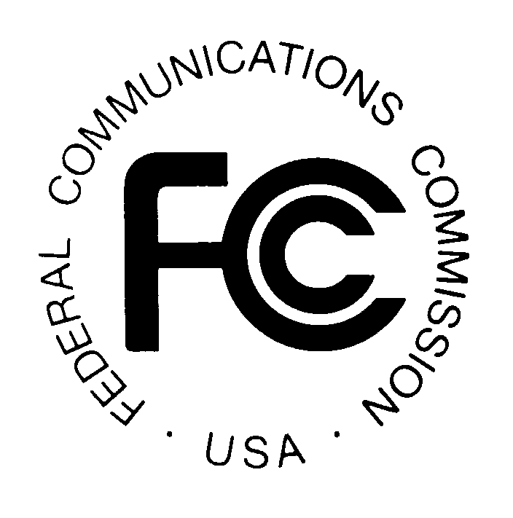

FEDERAL COMMUNICATIONS COMMISSION
445 TWELFTH STREET, S.W.
WASHINGTON, D.C. 20554
News Media Information: (202) 418-0500
Fax-On-Demand: (202) 418-2830
Internet: http://www.fcc.gov
ftp.fcc.gov

Released: January 30, 2001 DA 01-188

INTERNATIONAL BUREAU AND ENFORCEMENT BUREAU ANNOUNCE PROGRAM TO INCREASE COMPLIANCE WITH LICENSING REQUIREMENTS FOR CARRIERS THAT PROVIDE INTERNATIONAL TELECOMMUNICATIONS SERVICES AND OPERATORS OF INTERNATIONAL TELECOMMUNICATIONS FACILITIES PURSUANT TO SECTION 214 OF THE COMMUNICATIONS ACT AND SECTIONS 34-39 OF THE SUBMARINE CABLE LANDING LICENSE ACT
1. The International Bureau has received a number of requests for nunc pro tunc approval of belatedly filed applications for authority to provide international telecommunications services under Section 214 of the Communications Act of 1934, as amended. The International Bureau also has received requests for nunc pro tunc approval of other belatedly filed applications; specifically, requests for authority to assign or transfer control of existing international Section 214 authorizations, and to assign or transfer control of common carrier and non-common carrier submarine cable landing licenses. These requests suggest that there may be some carriers providing international telecommunications services, or operators operating international telecommunications facilities, without proper authority.
2. In light of this, and particularly in light of the fact that the Commission has streamlined its rules as competition in international markets has developed, the International Bureau is taking steps to ensure that international carriers and operators are in compliance with the rules and that its records regarding authorized carriers and operators are current and accurate. Timely filed applications and accurate records will serve the public interest and protect consumers by ensuring that the Commission has the information necessary to enforce its rules, regulations and policies governing carriers and operators that provide U.S. international service. Accordingly, the International Bureau is announcing the commencement of a 90-day period during which carriers are encouraged to apply for necessary authorizations. The International Bureau does not expect to initiate enforcement action against these carriers and operators during this 90-day period. At the end of the 90-day period, the International Bureau will refer cases of noncompliance to the Enforcement Bureau for appropriate enforcement action.
Authorization and Licensing Requirements
3. The Commission’s authorization and licensing requirements for carriers providing international telecommunications services and operators of international telecommunications facilities include the following:
Section 214 Authorizations: Common carriers seeking to provide international telecommunications services or to construct, acquire, or operate international telecommunications facilities must seek from the Commission an authorization pursuant to Section 214 of the Communications Act. In addition, Section 63.18 of the Commission’s rules provides, in pertinent part, that:
Except as otherwise provided in this part, any party seeking authority pursuant to Section 214 of the Communications Act of 1934, as amended, to construct a new line, or acquire or operate any line, or engage in transmission over or by means of such additional line for the provision of common carrier telecommunications services between the United States, its territories or possessions, and a foreign point shall request such authority by formal application which shall be accompanied by a statement showing how the grant of the application will serve the public interest, convenience, and necessity.

The filing requirements of Section 63.18 apply to any entity that seeks to initiate the provision of international telecommunications services either in its own name or through one or more wholly-owned direct or indirect subsidiaries. Alternatively, the subsidiary may apply for its own Section 214 authorization prior to initiating service. Pursuant to section 20.15(d) of the Commission’s rules, the requirement to obtain prior authorization to provide international services applies to carriers providing commercial mobile radio services (“CMRS”).
4. Section 63.18 also applies to assignments and transfers of control of existing international Section 214 authorizations unless the assignment or transfer is a pro forma transaction covered by the provisions of Section 63.24. A pro forma assignment or transfer is one that does not involve a substantial change in ownership or control. In such a case, Section 63.24 of the Commission’s rules provides, in pertinent part, that “ [a] pro forma assignee must notify the [C]ommission no later than 30 days after the assignment is consummated.”
5. Submarine Cable Licenses: Carriers seeking to own or operate submarine cable facilities must file applications to obtain submarine cable landing licenses, including transfers of control or assignments of such licenses, or modifications of such licenses to add new licensees. Applications must be filed pursuant to the Submarine Cable Landing License Act, Executive Order No. 10530, and Section 1.767 of the Commission's Rules.

Process to Update International Bureau Records
6. The International Bureau believes it is necessary for carriers to timely file for and receive proper authorizations and licenses and to be otherwise in compliance with all applicable rules and policies. To that end, the International Bureau announces a 90-day period after which, pursuant to its authority under Sections 0.111 and 0.311 of the Commission's rules, it will refer to the Enforcement Bureau for appropriate enforcement action any carrier that is providing international telecommunications services or operator operating international telecommunications facilities without first receiving proper authorizations from the Commission under Section 214 of the Communications Act and Sections 34-39 of the Submarine Cable Landing License Act, respectively. The Enforcement Bureau will take into account voluntary disclosure of misconduct in determining an appropriate sanction. The 90-day period will commence on the date of publication of this notice in the Federal Register.
7. In addition, the Telecommunications Division of the International Bureau also takes this opportunity to advise carriers and operators that, commencing with the date of publication of this public notice in the Federal Register, it will be extremely reluctant to grant requests for nunc pro tunc approval of belatedly filed applications. Such requests will be considered only in extraordinary circumstances.
8. For further information about the processing of applications under this program, contact Rebecca Arbogast, Chief, Telecommunications Division, International Bureau, at 202-418-1460 or Belinda Nixon, Telecommunications Division, International Bureau, at 202-418-1382 or e-mail at bnixon@fcc.gov.

By the Chief, Telecommunications Division, International Bureau and the Chief, Investigations & Hearings Division, Enforcement Bureau.

? 47 U.S.C. § 214.
47 C.F.R. § 63.18.
Section 63.21(i) of the rules permits an authorized carrier to provide service through one or more wholly-owned subsidiaries, provided the authorized carrier notifies the Commission within 30 days after the subsidiary initiates service. The notification must contain the information required by Section 63.21(i). 47 C.F.R. 63.21(i).
CMRS carriers are exempt, however, from certain tariffing requirements with respect to the provision of international services. See 47 C.F.R. § 20.15(d).
47 C.F.R. § 63.24. This section also provides a detailed definition of which kinds of transactions constitute a pro forma transfer or assignment.
? An Act Relating to the Landing and Operation of Submarine Cables in the United States, 47 U.S.C. §§ 34-39 ("Cable Landing License Act").
Exec. Order No. 10530, reprinted as amended in 3 U.S.C.A. § 301 app. at 459-60 (1994).
47 C.F.R. § 1.767.
Cf. Biennial Regulatory Review -- Amendment of Parts 0, 1, 13, 22, 24, 26, 27, 80, 87, 90, 95, 97, and 101 of the Commission's Rules to Facilitate the Development and Use of the Universal Licensing System in the Wireless Telecommunications Services, Memorandum Opinion and Order on Reconsideration, WT Docket No. 98-20, 14 FCC Rcd 11476, 11485 ¶¶ 20-22 (1999).

