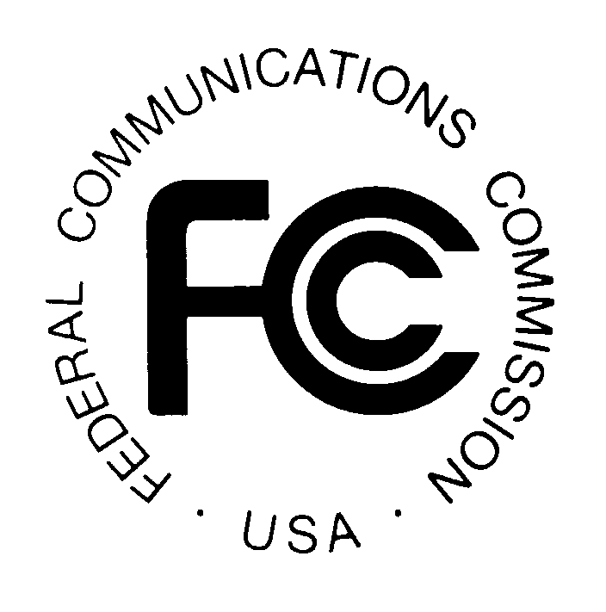 PUBLIC NOTICE
News media information 202 / 418-0500
Fax-On-Demand 202 / 418-2830
Internet: http://www.fcc.gov
ftp.fcc.gov

Federal Communications Commission
445 12th Street, S.W.
Washington, DC 20554

Released: June 23, 1999

Prepared by the Office of the Secretary

Ex Parte Presentations and Post-Reply Comment Period Filings
in Permit-But-Disclose Proceedings

The following is a list of ex parte presentations and Post-Reply Comment Period Filings received by the Secretary of the Commission on or before June 17,1999. For your reference, a public notice released June 10, 1999, briefly describes the most commonly listed docket numbers; this notice can be found at the FCC's Internet website as cited above. Copies of the following written presentations and memoranda reporting oral presentations, if they relate to docket proceedings, are available for inspection and copying in the appropriate docket in the FCC Reference Center (Room CY-A257, 445 12th Street, SW Washington, D.C.) which is open Monday through Friday, 9:00 AM to 4:30 PM. After a brief period, presentations concerning non-docketed proceedings are available only in the appropriate bureau. The duplicating contractor, ITS, Inc., will provide, for a fee, copies of the material listed below. ITS, Inc. (202-857-3800) is located in Room CY-B400, and has offices at 1231 20th St., N.W., Washington D.C. For additional information, contact Barbara Lowe, Office of the Secretary, at (202) 418-0310.

Date Received | Presentation by: | Presentation to: | Oral | Written | Docket No.
6/17 | State Members, The Federal-State Joint Board on Separations | Chairman Kennard Cmsr. Ness Cmsr. Powell |  | X X X | CC 80-286
6/17 | Silicon Valley Smart Corridor Steering Committee | Common Carrier Bureau |  | X | CC 92-105
6/17 | Warburg, Pincus & Co. | Chairman Kennard | X |  | CC 92-237
6/17 | Cellular Telecommunications Industry Assn. | Wireless Telecommunications Bureau |  | X | WT 94-102
6/16 | METROCOM.COM | Ofc. of Engineering & Technology Wireless Telecommunications Bureau | X X |  | GC 95-21
6/17 | Department of Education, State of Tennessee | Common Carrier Bureau | X |  | CC 96-45
6/17 | Public Utility Commission of Texas | Common Carrier Bureau |  | X | CC 96-98
6/17  6/17 | U S WEST  BellSouth Corporation | Common Carrier Bureau  Common Carrier Bureau | X | X | CC 98-121
6/17 | BellSouth Corporation | Common Carrier Bureau |  | X | CC 98-137
6/17  6/17 | Indiana Utility Regulatory Commission  SBC Telecommunications, Inc. et al. | Chairman Kennard Cmsr. Ness Cmsr. Furchtgott-Roth Cmsr. Powell Cmsr. Tristani Common Carrier Bureau  Ofc. of Engineering & Technology Ofc. of Plans & Policy Common Carrier Bureau | X X X | X X X X X X | CC 98-141
6/17 | Bell Atlantic | Ofc. of Engineering & Technology |  | X | CC 98-184 CC 98-141
6/17 | Key Broadcasting, Inc. | Chairman Kennard Cmsr. Ness Cmsr. Furchtgott-Roth Cmsr. Powell Cmsr. Tristani |  | X X X X X | MM 99-25
6/15 | UTC, the Telecommunications Assn. | Ofc. of Cmsr. Tristani | X |  | WT 99-87
Non-docketed Proceedings

6/17 | Silicon Valley Smart Corridor Steering Committee | Common Carrier Bureau |  | X | File No. NSD-L-99-24
6/17 | Warburg, Pincus & Co. | Chairman Kennard | X |  | File No. NSD 98-151
6/17 | Public Utility Commission of Texas | Common Carrier Bureau |  | X | File No. NSD L-98-136
6/17 | ALLTEL Corporation | Ofc. of Cmsr. Ness | X |  | File No. CCB/CPD 99-1
6/17 | PanAmSAT Corporation | Ofc. of Cmsr. Ness Ofc. of Cmsr. Furchtgott-Roth Ofc. of Cmsr. Powell Ofc. of Cmsr. Tristani International Bureau Wireless Telecommunications Bureau | X X X X X X |  | File No. 1164-DSE-MP/L-98 et al.
6/17 | TMI Communications Company | Ofc. of Chairman Kennard | X |  | File No. 730-DSE-P/L-98
6/17 | COMSAT Corporation | Ofc. of Chairman Kennard Ofc. of Cmsr. Ness Ofc. of Cmsr. Furchtgott-Roth Ofc. of Cmsr. Powell Ofc. of Cmsr. Tristani | X X X X X |  | File No. 60-SAT-ISP-97

-FCC-

