PUBLIC NOTICE
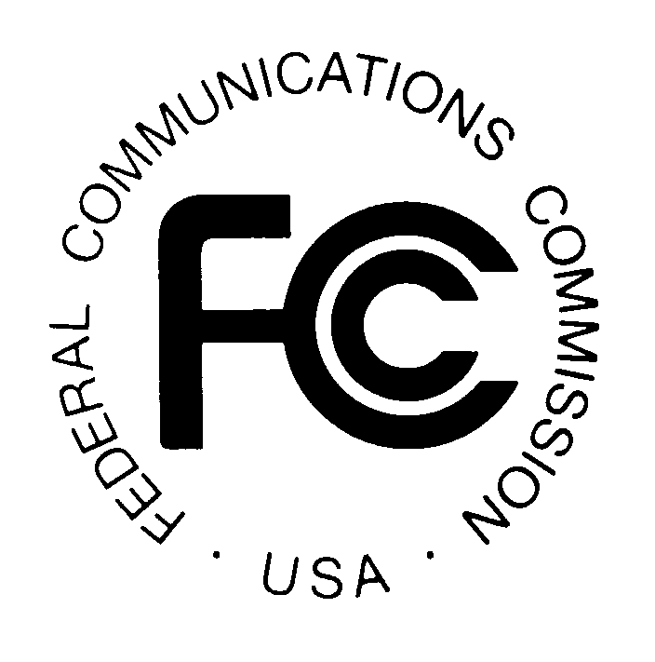

FEDERAL COMMUNICATIONS COMMISSION News Media Information: (202) 418-0500
445 12th STREET, S.W. Fax-On-Demand: (202) 418-2830

WASHINGTON, D.C. 20554 Internet: http://www.fcc.gov

ftp.fcc.gov

DA 00-2831
December 15, 2000

Low Power FM Filing Window

FCC to Accept Low Power FM Applications January 16 through January 22, 2001 for American Samoa, Colorado, Delaware, Hawaii, Idaho, Missouri, New York, Ohio, South Carolina, South Dakota, and Wisconsin.

The Mass Media Bureau (MMB) announces an application filing window for construction permits for Low Power FM (LPFM) stations in the states and territories listed above. The window will open on January 16, 2001 and close on January 22, 2001.

The Commission established the new LPFM service on January 20, 2000 to create new broadcasting opportunities for locally-based organizations to serve their communities. An LPFM station will serve an area with a radius of approximately 3.5 miles, with a maximum power level of 100 watts.

On March 27, 2000, the Commission conducted a lottery to determine the order in which applications would be accepted for LPFM stations from applicants in each of five pre-defined groups of states and territories. In a Public Notice announcing the results of that lottery, the Commission indicated that it would announce successive filing windows for each group of states and territories. The first filing window was announced at the end of April, 2000 and was opened from May 30, 2000 until June 8, 2000. The second window was announced at the end of July, 2000 and was opened from August 28, 2000 until September 1, 2000.
Applicants should be aware that legislation currently pending before the United States Congress would affect the availability of certain frequencies for LPFM stations. Prior to submitting LPFM applications, applicants should consult the Federal Communications Commission’s website and channel locator program to determine whether the availability of frequencies for LPFM stations has changed as a result of legislation.

Scope. The window will be for new LPFM station applications that specify LP100 stations that would operate with 50-100 watts effective radiated power. The Commission will accept applications proposing transmitter locations within the following U.S. states and territories: American Samoa, Colorado, Delaware, Hawaii, Idaho, Missouri, New York, Ohio, South Carolina, South Dakota, and Wisconsin. A public notice announcing a subsequent LP100 LPFM filing window for the next group of ten states and other jurisdictions will be released in approximately three months.

Filing Requirements. LPFM applications filed during this window must protect all FM, FM Translator, FM Booster, and TV Channel 6 authorizations. LPFM applications also must protect pending broadcast applications in these services that were filed prior to the date of this Notice, along with LPFM applications filed in the previous filing windows. Finally, LPFM applications must protect existing vacant FM allotments. See 47 C.F.R. §§ 73.807 and 73.825. An LPFM application that fails to protect these authorizations, applications, and allotments will be dismissed with no opportunity to correct the deficiency. Each applicant must be a nonprofit educational organization, a nonprofit educational institution or must propose a noncommercial public safety radio service. Please note, when completing FCC Form 318, the name of the organization or institution must be entered in Section I, Question 1, in the box marked “Legal Name of the Applicant.” Applicants also must be community-based. See 47 C.F.R. § 73.853.

Participation. Those wishing to participate in this LPFM window must electronically complete and timely file FCC Form 318, Application for Construction Permit for a Low Power FM Broadcast Station. No fee is required when filing FCC Form 318.

Applications must be filed during the window. Applications filed earlier in the window will not receive any preference over those filed later in the window. Applications filed before January 16, 2001 or after January 22, 2001 will be returned. Incomplete and patently defective applications will be dismissed without any opportunity to amend. Applications specifying transmitter locations in jurisdictions not included in this filing window will be dismissed.

Electronic Filing. Applicants must file Form 318 electronically. Each applicant filing electronically will benefit from “error checks” in the Form 318 computer software program and obtain immediate confirmation of the receipt of its application by the Commission. In addition, electronic filing will expedite the Commission’s application review process.

Applicants filing electronically also are encouraged to file as early in the window as possible. Applications will not be made publicly available until after the close of the window. Moreover, electronically filed applications may be accessed and amended at any point prior to the close of the window through the Consolidated Database System (CDBS) online electronic forms filing system, located at the following site: http://www.fcc.gov/mmb.

Electronic filing instructions are available in the CDBS User’s Guide. The Guide can be accessed from the MMB web site, above, by clicking on the “CDBS” link. This action will take the user to the Mass Media Bureau CDBS Electronic Filing System site. The user should then click on the “Go to CDBS User’s Guide” link. Internet access to the CDBS online electronic forms filing system requires, at a minimum, a browser such as Netscape version 3.04 or Internet Explorer version 3.51, or later. The Commission must receive electronically filed applications no later than 11:59 PM EST on January 22, 2001.

Finding an LPFM Station Channel. Applicants may use the MMB LPFM Channel Finder to help determine if a proposed transmitter site would meet minimum LPFM station spacing requirements. This internet-based utility is available on the FCC web site at: http://www.fcc.gov/mmb/asd/lpfm. The LPFM Channel Finder incorporates the technical changes implemented by the LPFM Memorandum Opinion and Order (released September 28, 2000). The site also provides additional information on the new LPFM service, including the text of the LPFM Report and Order, specific rule requirements for LPFM applicants, and methods to determine the coordinates of an applicant’s proposed transmitter site.

Single Application Limitation. An applicant may not file more than one application in this window. Currently, no one except government, public safety and transportation organizations may hold an attributable interest in more than one LPFM station. Section 73.855. Accordingly, a second application filed by an applicant in this window would be treated as a “conflicting” application subject to dismissal under Section 73.3518. See also Section 73.801 (making Section 73.3518 applicable to LPFM stations). This restriction applies even where more than one frequency is available to an applicant at its proposed transmitter site.

For additional information, contact the Commission’s Consumer Information Bureau at (888) CALL-FCC, or visit the Commission’s website at: http://www.fcc.gov/lpfm.

Copies of this Public Notice are available in accessible formats (Braille, large print and audio cassette) by contacting Brian Millin at (202) 418-7426 (voice); 418-7365 (TTY).

- FCC -

See Creation of Low Power Radio Service, Report and Order, MM Docket No. 99-25, FCC 00-19 (released January 27, 2000) (“LPFM Report and Order”), and Memorandum Opinion and Order, FCC 00-349 (released September 28, 2000).

