PUBLIC NOTICE
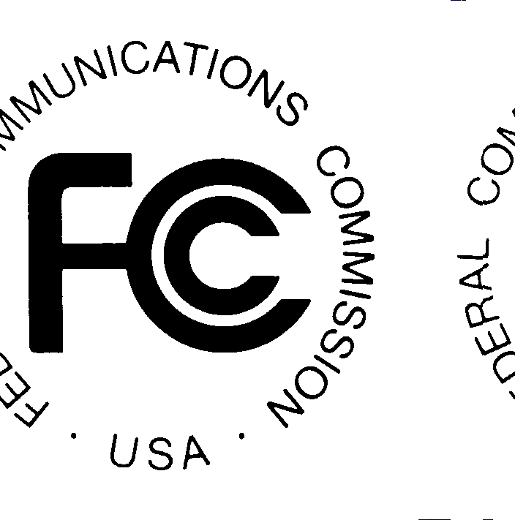
FEDERAL COMMUNICATIONS COMMISSION
445 12th St. SW
WASHINGTON, D.C. 20554

News media information 202/418-0500 Fax-On-Demand 202/418-2830 Internet: http://www.fcc.gov ftp.fcc.gov

DA 00-1140
Released: May 31, 2000

TECHNOLOGICAL ADVISORY COUNCIL TO HOLD FIFTH MEETING

The Technological Advisory Council ("Council"), will hold its fifth meeting on Wednesday, June 28, at 10:00 a.m. at the Federal Communications Commission, 445 12th St. S.W., Room TW-C305, Washington, D.C. 20554. The Council was established by the Federal Communications Commission to enable a wide array of distinguished technologists from industry, academia, government, and the public to provide recommendations to the FCC concerning technological developments in the communications industry.

The subjects that will be considered include: (1) software defined radios and similar devices, and ways that the availability of such technologies might affect the FCC's traditional approaches to spectrum management in light of electromagnetic noise levels, including the possibility of creating a “bill of rights” governing the behavior of intelligent communications devices; (2) current technological trends in telecommunications services, including changes that might decrease, rather than increase, the accessibility of telecommunications services by persons with disabilities, and ways by which the FCC might best communicate to designers of emerging telecommunications network architectures, the requirements for accessibility; (3) telecommunications common carrier network interconnection issues and how the Council should address these; (4) additional issues that the Council may choose to address in the future.

The Council may also consider such other issues as may come before the Council at the meeting.
Members of the general public may attend the meeting. Admittance, however, will be limited to the seating available. Brief oral comments to the Council may be made with prior notice to, and approval by, the Federal Communications Commission's Designated Federal Officer for the Technological Advisory Council, David Farber (e-mail: DFARBER@FCC.GOV).

For further information, contact Kent Nilsson at 202-418-0845 or TTY 202-418-2989.

